Reliability depends on similar results or consistent event occurrence, but it is unrealistic to prove something based on consistency. We cannot account for all the possible objections.

Philosophy of science is concerned with bringing us the truth through studying all assumptions, foundations, methods, and implications of science and using science. This concept is fundamental to how science is done based on data. According to Karl

Popper, it is always better to be tested with the risk of being wrong, which will

lead to more knowledge than one who could not be tested but claims to explain

everything.

The standard way to argue based on the data is variables (variables that the observed data are just statistical fluctuations and not caused due to unusual) and rejecting them.

Such a variable is the Null Hypothesis.

Before that, let's discuss the Null Hypothesis's history and significance to the statistical world. R. A. Fisher introduced the concept. Fisher, somewhat arbitrarily, said that if your random shuffling produced the observed differences less than one in twenty times, random error is not the cause, and there must be a natural treatment effect. This is the origin of the "p-value less than 0.05" criterion.

The "null hypothesis" is the state of the world if there were no treatment effect (or, in the case of the astronomers, no unusual measurement error). The null hypothesis is helpful because it can be tested to conclude whether there is a relationship between two measured phenomena. The exact data-generating mechanism produces all data.

The null hypothesis is supposed to be the default, accepted idea, the thing you'd believe if the data didn't change your mind, but this concept is often either ignored or applied very loosely nowadays. Instead, people often claim that the null hypothesis *must* assume that nothing happens, that there's no difference between two groups, or that a particular parameter is zero. None of these restrictions is necessary or sufficient for correctly applying p-values. It is essential to set some threshold accepting/rejecting the null hypothesis, then estimate how likely the hypothesis is, and then compare this estimate to the threshold to decide.

The probability of getting an effect is at least as extreme or contradictory as

the one we have plot ȳ, assuming the Null hypothesis is true and that when we

get a p-value. (H0) is the hypothesis we postulate to be true, and we might like to reject it. For example, we are building a sampling distribution based on the assumption that H0: µ = 0 is true. And we are randomly plotting ȳ on our axis.



College of Business

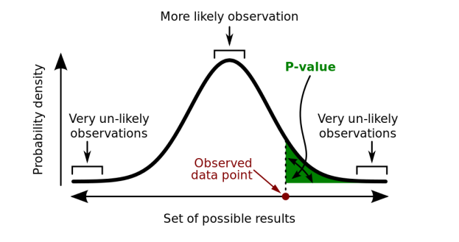

If the green color area is small, it tells it is highly unlikely that we will get another observation at least as contradicting as the previous sample.

The P-value tells us whether a pattern in our data is surprising, under the “null hypothesis” that patterns are produced only by random variation. A p-value, or probability value, is a number describing how likely it is that your data would have occurred under the null hypothesis of your statistical test.

Well, there is a lot of misconception related to p values that have come across. Before that, I would like to introduce Black Swan Theory. A theory that explains the occurrence of an event is rare, and someone has not predicted it at all. Just like the p-value, the probability is very unlikely for the event to occur. So, the question is Should we ignore that p-value? Because according to the Black Swan theory, even though the probability is minuscule, it doesn’t give us 100% confidence in rejecting it. Then, should we accept it? Again, we are not 100% sure in this case either.

So finally, we have come to the concept that if we are not rejecting the null hypothesis, it doesn’t necessarily accept it. You see, null hypothesis significance testing is an algorithm. It tells you that, after you make a measurement, you need to calculate the p-value associated with the null hypothesis H0 and then declare that you reject H0 if p is small enough, say, p<α, and otherwise do nothing (or “fail to reject”). The value α here is called the significance level.

Now, the magical thing is that, once you set the significance level, if you keep applying this same algorithm to every decision you’re making, you’re guaranteed to wrongly reject the null just a fraction α of the time. Smaller p-values do not necessarily imply the presence of more significant or more important effects, and larger p-values do not imply a lack of importance or even lack of effect.

So, if the p-value is less than 0.05 is typically considered to be statistically significant, in which case the null hypothesis should be rejected. A p-value more significant than 0.05 means that deviation from the null hypothesis is not statistically significant, and the null hypothesis is not rejected.



College of Business

It’s common to learn about and even use p-values regularly, all while ignoring an essential concept at work behind the scenes: the alternative hypothesis. Confusion abounds about what this is. Some say it must be the negation of the null hypothesis, but this is unnecessary and even counterproductive. Instead, please think of the alternative as simply a second hypothesis, H1, that we wish to contrast with the null and that we believe might be true instead of the null.

**Citations-**

Six Things to Know about P-Values – Versta Research. <https://verstaresearch.com/blog/six-things-to-know-about-p-values/>

P-Value: What It Is, How to Calculate It, and Why It Matters - Investopedia. <https://www.investopedia.com/terms/p/p-value.asp>

https://fivethirtyeight.com/features/statisticians-found-one-thing-they-can-agree-on-its-time-to-stop-misusing-p-values/

<https://scientistseessquirrel.wordpress.com/2015/02/09/in-defence-of-the-p-value/>



College of Business

Who Invented the Null Hypothesis? | Elder Research. <https://www.elderresearch.com/blog/who-invented-the-null-hypothesis/>



College of Business